CHAPTER 2-9

properties of regular languages

- The language a*b* is regular. The language A^{n}B^{n}={a^{n}b^{n}:n≥0} is not regular (intuitively because it is not possible for a FSM to remember how many a's it has read).
- Given a language L, how can we know whether or not it is regular? Just because you cannot design a FSM to accept L does not mean no such FSM exists.

Show L is regular by showing L is finite

Theorem Every finite language is regular.
Proof If L is the empty set, then it is defined by the regular expression ∅ and so is regular. If it is any finite language composed of the strings s₁, s₂, … s_{n} for some positive integer n, then it is defined by the regular expression s₁∪s₂∪…∪s_{n} and so it too is regular.

Ex2-9-1 Show L= L₁∩L₂, where L₁={a^{n}b^{n}, n>0}, and L₂={b^{n}a^{n}, n>0} is regular.
L = ∅, so L is regular.

Ex2-9-2 Show L={w∈{0-9}*: w is the social security number of the current US president} is regular.
L is regular because it is finite. It does not matter that we do not know what strings are in L exactly.

Show L is regular by closure properties of regular languages

Theorem: The set of RLs is closed under union, concatenation, and Kleene closure. That is, if L₁ and L₂ are RLs, then L₁∪L₂, L₁L₂, and L₁* are also RLs.
Proof : Because L₁ and L₂ are RLs, there must be NDFSMs that accept them. Let NDFSM₁ accepts L₁ and NDFSM₂ accepts L₂. Assume NDFSM₁ and NDFSM₂ are in desirable form. The following NDFSM accepts the language L₁∪L₂:
ε ε
-
-1
-2

NDFSM₁ NDFSM₂
+1
+2

The following NDFSM accepts the language L₁L₂:
NDFSM₁ ε NDFSM₂
-1
(-)2
(+)1
+2

The following NDFSM accepts the language L₁*:
-1

ε NDFSM₁ ε

+1

Theorem The set of RLs is closed under complementation. That is, if L is RL, then L' is also RL.
Proof If L is RL, then there is some DFSM (must include all dead states) that accepts L. Reverse the final status of each state, i.e., if it is a final state, make it a nonfinal state, and if it is a nonfinal state, make it a final state. Now, if an input string formerly ended in a nonfinal state, it now ends in a final state and vice versa. This new machine accepts L'.

Ex2-9-4 A DFSM that accepts L={aba, abb}:
-

+
a b a, b

b a a, b

a,b
A DFSM that accepts L':
-+
+
+

a b a, b

b a a, b
+

a,b

Theorem: The set of RLs is closed under intersection. That is, if L₁ and L₂ are RLs, then L₁∩L₂ is also RL.
Proof: Because L₁ and L₂ are RLs, there must be DFSMs that accept them. Let DFSM₁ accepts L₁ and DFSM₂ accepts L₂. We will construct a DFSM₃ which accepts L₁∩L₂.
Let DFSM₁ accepts AA=all words that have a double a somewhere in them:
a
-x₁
x₂
+x₃
b a a,b
b
Let DFSM₂ be the machine which accepts EVENEVEN:
b
±y₁
y₂

b
a a a
a
b
y₃
y₄

b
We will build a DFSM₃ with states (x_{j}, y_{j}) that accepts AA∩EVENEVEN. The x-component keeps track of which x state the string would be in if it were running on DFSM₁ alone, the y-component keeps track of which y state the string would be in if it were running on DFSM₂ alone. If both the x-component and the y-component is a + state, (x_{j}, y_{j}) is a + state. We will construct DFSM₃=(K', δ', s', A') as follows:
1. s'={x₁, y₁} //start state must combine start state for DFSM₁ and start state for DFSM₂
2.
{x₁, y₁} | a | {x₂, y₃}
 | b | {x₁, y₂}
{x₂, y₃} | a | {x₃, y₁}
 | b | {x₁, y₄}
{x₁, y₂} | a | {x₂, y₄}
 | b | {x₁, y₁}
{x₃, y₁} | a | {x₃, y₃}
 | b | {x₃, y₂}
{x₁, y₄} | a | {x₂, y₂}
 | b | {x₁, y₃}
{x₂, y₄} | a | {x₃, y₂}
 | b | {x₁, y₃}
{x₃, y₃} | a | {x₃, y₁}
 | b | {x₃, y₄}
{x₃, y₂} | a | {x₃, y₄}
 | b | {x₃, y₁}
{x₂, y₂} | a | {x₃, y₄}
 | b | {x₁, y₁}
{x₁, y₃} | a | {x₂, y₁}
 | b | {x₁, y₄}
{x₃, y₄} | a | {x₃, y₂}
 | b | {x₃, y₃}
{x₂, y₁} | a | {x₃, y₃}
 | b | {x₁, y₂}
3. K'={{x₁, y₁}, {x₂, y₃}, {x₁, y₂}, {x₃, y₁}, {x₁, y₄}, {x₂, y₄}, {x₃, y₃}, {x₃, y₂}, {x₂, y₂}, {x₁, y₃}, {x₃, y₄}, {x₂, y₁}}
4. A'={{x₃, y₁}}

Here is what DFSM₃ looks like:

a
{x₃, y₄}
{x₃, y₂}

a
a b a
{x₂, y₂}
-{x₁, y₁}
{x₁, y₂}
{x₂, y₄}

b b b b a
b b
a b
b
a
{x₂, y₁}
{x₂, y₃}
b
{x₁, y₃}
{x₁, y₄}
a b
a b a
a
{x₃, y₃}
+{x₃, y₁}

a

The string aabbab will be rejected, while the string ababaabb will be accepted.

Ex2-9-5 Show L={w∈{a, b}*:w contains an even number of a’s and an odd number of b’s and all a’s come in runs of three} is regular.
Observe that L=L₁∩L₂, where L₁={w∈{a, b}*:w contains an even number of a’s and an odd number of b’s}, and L₂={w∈{a, b}*:all a’s come in runs of three}.
L₁ is regular because it is accepted by the following DFSM
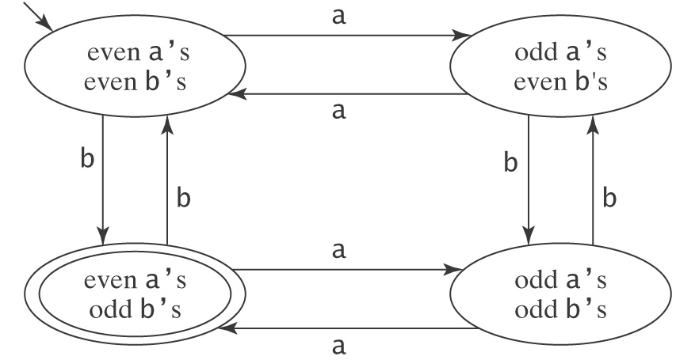
L₂ is regular because it is accepted by the following NDFSM
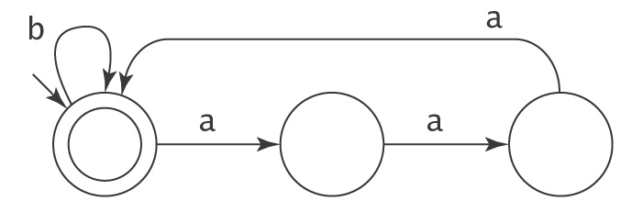
Since RL is closed under intersection, L is regular.

Theorem The set of RLs is closed under difference. That is, if L₁ and L₂ are RLs, then L₁-L₂ is also RL.
Proof L₁-L₂ = L₁∩L₂'
Since L₂ is regular, so is L₂'. Since L₁ is regular, then so is L₁∩L₂'. Then so is L₁-L₂.

Theorem The set of RLs is closed under reverse. That is, if L is RL, then L^{R} is also RL.
Proof Suppose L is regular, so there is a NDFSM₁ in desirable form for it. Build a NDFSM₂ from NDFSM₁ by changing the – state to a + state and the + state to a – state, and reverse the direction on all the edges. If there is a path in NDFSM₁ that accepts w, it is fairly easy to see that there is a path in NDFSM₂ that accepts w^{R}. If there is a path in NDFSM₂ that accepts w^{R}, it is fairly easy to see that there is a path in NDFSM₁ that accepts w. So NDFSM₂ accepts L^{R}.

Ex2-9-6 The following NDFSM₁ accepts L={all words ending in a}. Build a NDFSM₂ that accepts L^{R}.
b a a
-x₁
+x₂

b
Put NDFSM₁ in desirable form (accepts all words ending in a):
b a a
x₁
x₂

b
ε ε
+
-

NDFSM₂ (accepts all words starting in a):
b a a
x₁
x₂

b
ε ε
-
+

Homework problems

            - For each of the following languages L, state whether or not L is regular. Justify your answer.
              - {a^{i}b^{j} : i, j ≥ 0 and i + j = 5}. Hint: what are the strings in this language?
              - {w ∈ {Y, N}* : w contains at least two Y’s and at most two N’s}. Hint: think intersection.

            - Define the class IR to be the class of languages that are both infinite and regular. Is the class IR closed under:
              - Union (hint: yes, so prove it)
              - Intersection (hint: no, so come up with a counter example)

            - The language L={s|s has a double a} is defined by the following DFSM:
DFSM: b a a a, b
-x1
+x3
x2

b

              - Construct a DFSM that accepts L' using the algorithm discussed in this chapter.
              - Construct a NDFSM that accepts L^{R} using the algorithm discussed in this chapter.

            - L₁={s|s has a double a}, L₂={s|s has an even number of a's}. They are defined by the following DFSMs:
DFSM₁: b a a a, b
-x1
+x3
x2

b

DFSM₂: b a b
±y1
y2

a
Construct a DFSM that accepts L₁∩ L₂ using the algorithm discussed in this chapter.

